**Operating System and Design (19CS2106A)**

**Advanced Lab- 2**

**XV6 design, implementation, and customization.**

**1.TOUCH**

STEP1: Open Vi Editor

Syntax : vi touchex.c

STEP2: Type the below code(Press ‘i’ to enter into insert mode

#include "types.h"

#include "stat.h"

#include "user.h"

#include "fcntl.h"

#include "fs.h"

int main(int argc,char *argv[])

{

if(argc<2)

{

printf(1,"Usage: touch [files]...\n");

exit();

}

int i,err;

for(i=1;i<argc;i++)

{

if((err=open(argv[i],O_CREATE|O_RDWR)) < 0)

{

printf(1,"touch: error where creating %s\n",argv[i]);

exit();

}

close(err);

}

exit();

}

STEP 3: Press Esc : wq to save and quit from the editor after typing the program.

STEP 4: Open Makefile

Syntax: vi Makefile

STEP 4: IN Makefile program do the following changes in two sections:

In the Makefile, there are two places in which we need to put entries.

Find the place with some lines like the following.

We have to add a line as shown below to notify about our new program.

UPROGS= \

_cat\

_echo\

_forktest\

_grep\

_init\

_kill\

_ln\

_ls\

_mkdir\

_rm\

_sh\

_stressfs\

_usertests\

_wc\

_zombie\

_touchex\

Similarly, find the place with the lines like below.

Add an entry as shown to indicate that we have a program called my.c there.

EXTRA=\ mkfs.c ulib.c user.h cat.c echo.c forktest.c grep.c kill.c\

ln.c ls.c mkdir.c rm.c stressfs.c usertests.c wc.c zombie.c\ touchex.c\

printf.c umalloc.c\ README dot-bochsrc *.pl toc.* runoff runoff1 runoff.list\ .gdbinit.tmpl gdbutil\

Now, our Makefile and our user program is ready to be tested.

Enter the following commands to compile the whole system.

Syntax:

make clean

make

Now, start xv6 system on QEMU and when it booted up, run ls command

to check whether our program is available for the user.

Syntax:

make qemu-nox

$ls

Check whether touchex is listed in the output.If yes then use that as a command.

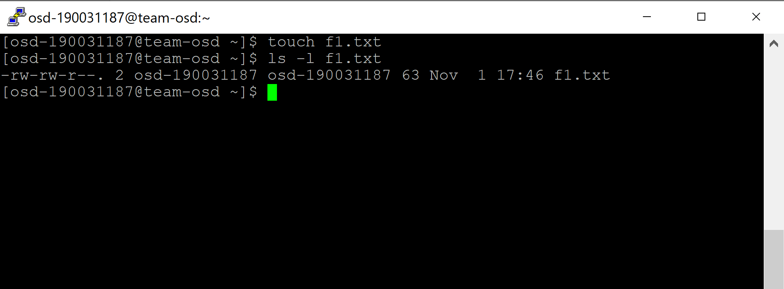

**OUTPUT**

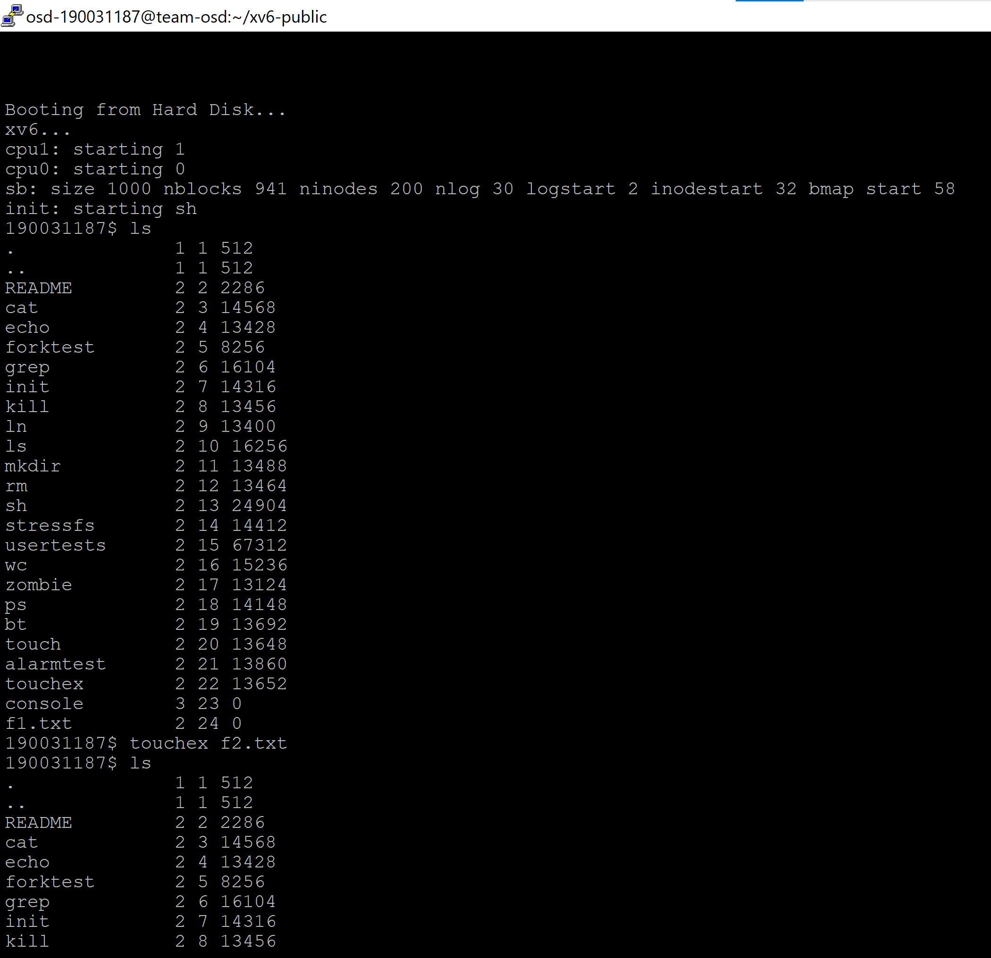

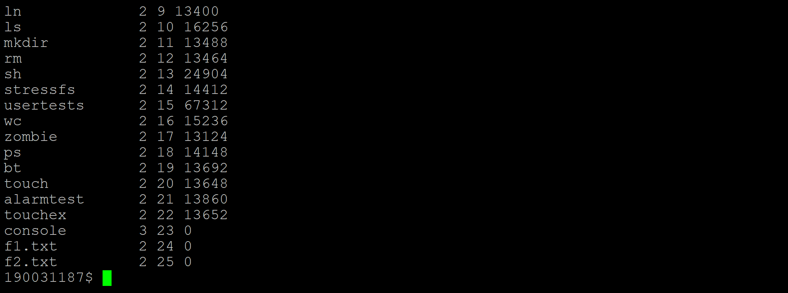

**2) TAIL COMMAND IN XV6:**

**STEP1: Open Vi Editor**

Syntax : vi tailex.c

**STEP2: Type the below code(Press ‘i’ to enter into insert mode)**

#include "types.h"

#include "stat.h"

#include "user.h"

char buf[1024]={'\\'};//Initialise buffer1

char buf2[1024]={'\\'};//Initialise buffer2

void tail(int fd,char *name, int x)

{

int i,n,m,l;

int tot_lines;

tot_lines=0;

int start;

while((n=read(fd,buf,sizeof(buf)))>0)

{

for(i=0;i<=n ;i++)

{

if(buf[i]=='\n')

{

tot_lines++; // Loop for total number of lines in the file

if(strcmp(name,"")==0){

printf(1,"\n");}

}

else

{

if(strcmp(name,"")==0){

if(buf[i] =='\0') // Check end of file

{

exit();

}

if(buf[i]!='\n')

{

printf(1,"%c",buf[i]);

}

else

{

printf(1,"\n");}

}

}

}

}

close(fd);

start = tot_lines-x;

l=0;

int fd2 = open(name,0); //Creating file descriptor 2

while((m=read(fd2,buf2,sizeof(buf2)))>0)

{

for(i=0;i<=m;i++)

{

if(buf2[i] == '\n')

l++;

if(l>=start)

{

if(buf2[i] !='\n' && l>=start)

{

printf(1,"%c",buf2[i]);

}

else

{

printf(1,"\n");

l++;

}

}

}

}

close(fd2);

if(n<0)

{

printf(1,"tail: error while reading \n");

exit();

}

}

int

main(int argc,char *argv[])

{

int fd,i;

if(argc<=1)

{

tail(0,"",10);

exit();

}

else if(argc==2)

{

for(i=1;i<argc;i++)

{

if((fd=open(argv[i],0))<0 )

{

printf(1,"Error in File Reading");

exit();

}

tail(fd,argv[i],10);

close(fd);

}

}

else if(argc==3)

{

char c[1024];

strcpy(c,argv[1]);

char *num_str=c;

num_str=num_str+1;

int x= atoi(num_str);

for(i=2;i<argc;i++)

{

if((fd=open(argv[i],0))<0 )

{

printf(1,"tail:error opening the %s\n",argv[i]);

exit();

}

tail(fd,argv[i],x);

close(fd);

}

}

else

{

printf(1,"tail: syntax error");

}

exit();

}

**STEP 3: Press Esc : wq to save and quit from the editor after typing the program.**

**STEP 4: Open Makefile**

Syntax: vi Makefile

**STEP 4: IN Makefile program do the following changes in two sections:**

In the **Makefile**, there are two places in which we need to put entries. Find the place with some lines like the following. We have to add a line as shown below to notify about our new program.

**UPROGS= \**

**_cat\**

**_echo\**

**_forktest\**

**_grep\**

**_init\**

**_kill\**

**_ln\**

**_ls\**

**_mkdir\**

**_rm\**

**_sh\**

**_stressfs\**

**_usertests\**

**_wc\**

**_zombie\**

**_tailex\**

Similarly, find the place with the lines like below. Add an entry as shown to indicate that we have a program called **my.c** there.

**EXTRA=\ mkfs.c ulib.c user.h cat.c echo.c forktest.c grep.c kill.c\ ln.c ls.c mkdir.c rm.c stressfs.c usertests.c wc.c zombie.c\ tailex.c\**

**printf.c umalloc.c\ README dot-bochsrc *.pl toc.* runoff runoff1 runoff.list\ .gdbinit.tmpl gdbutil\**

Now, our Makefile and our user program is ready to be tested. Enter the following commands to compile the whole system.

**Syntax:**

make clean

make

Now, start xv6 system on QEMU and when it booted up, run ls command to check whether our program is available for the user.

**Syntax:**

make qemu-nox

**$ls**

Check whether touchex is listed in the output.If yes then use that as a command.

**$tailex f1.txt**

**Output:**

Last 10 lines of the file f1.txt will be displayed by default

**OUTPUT**

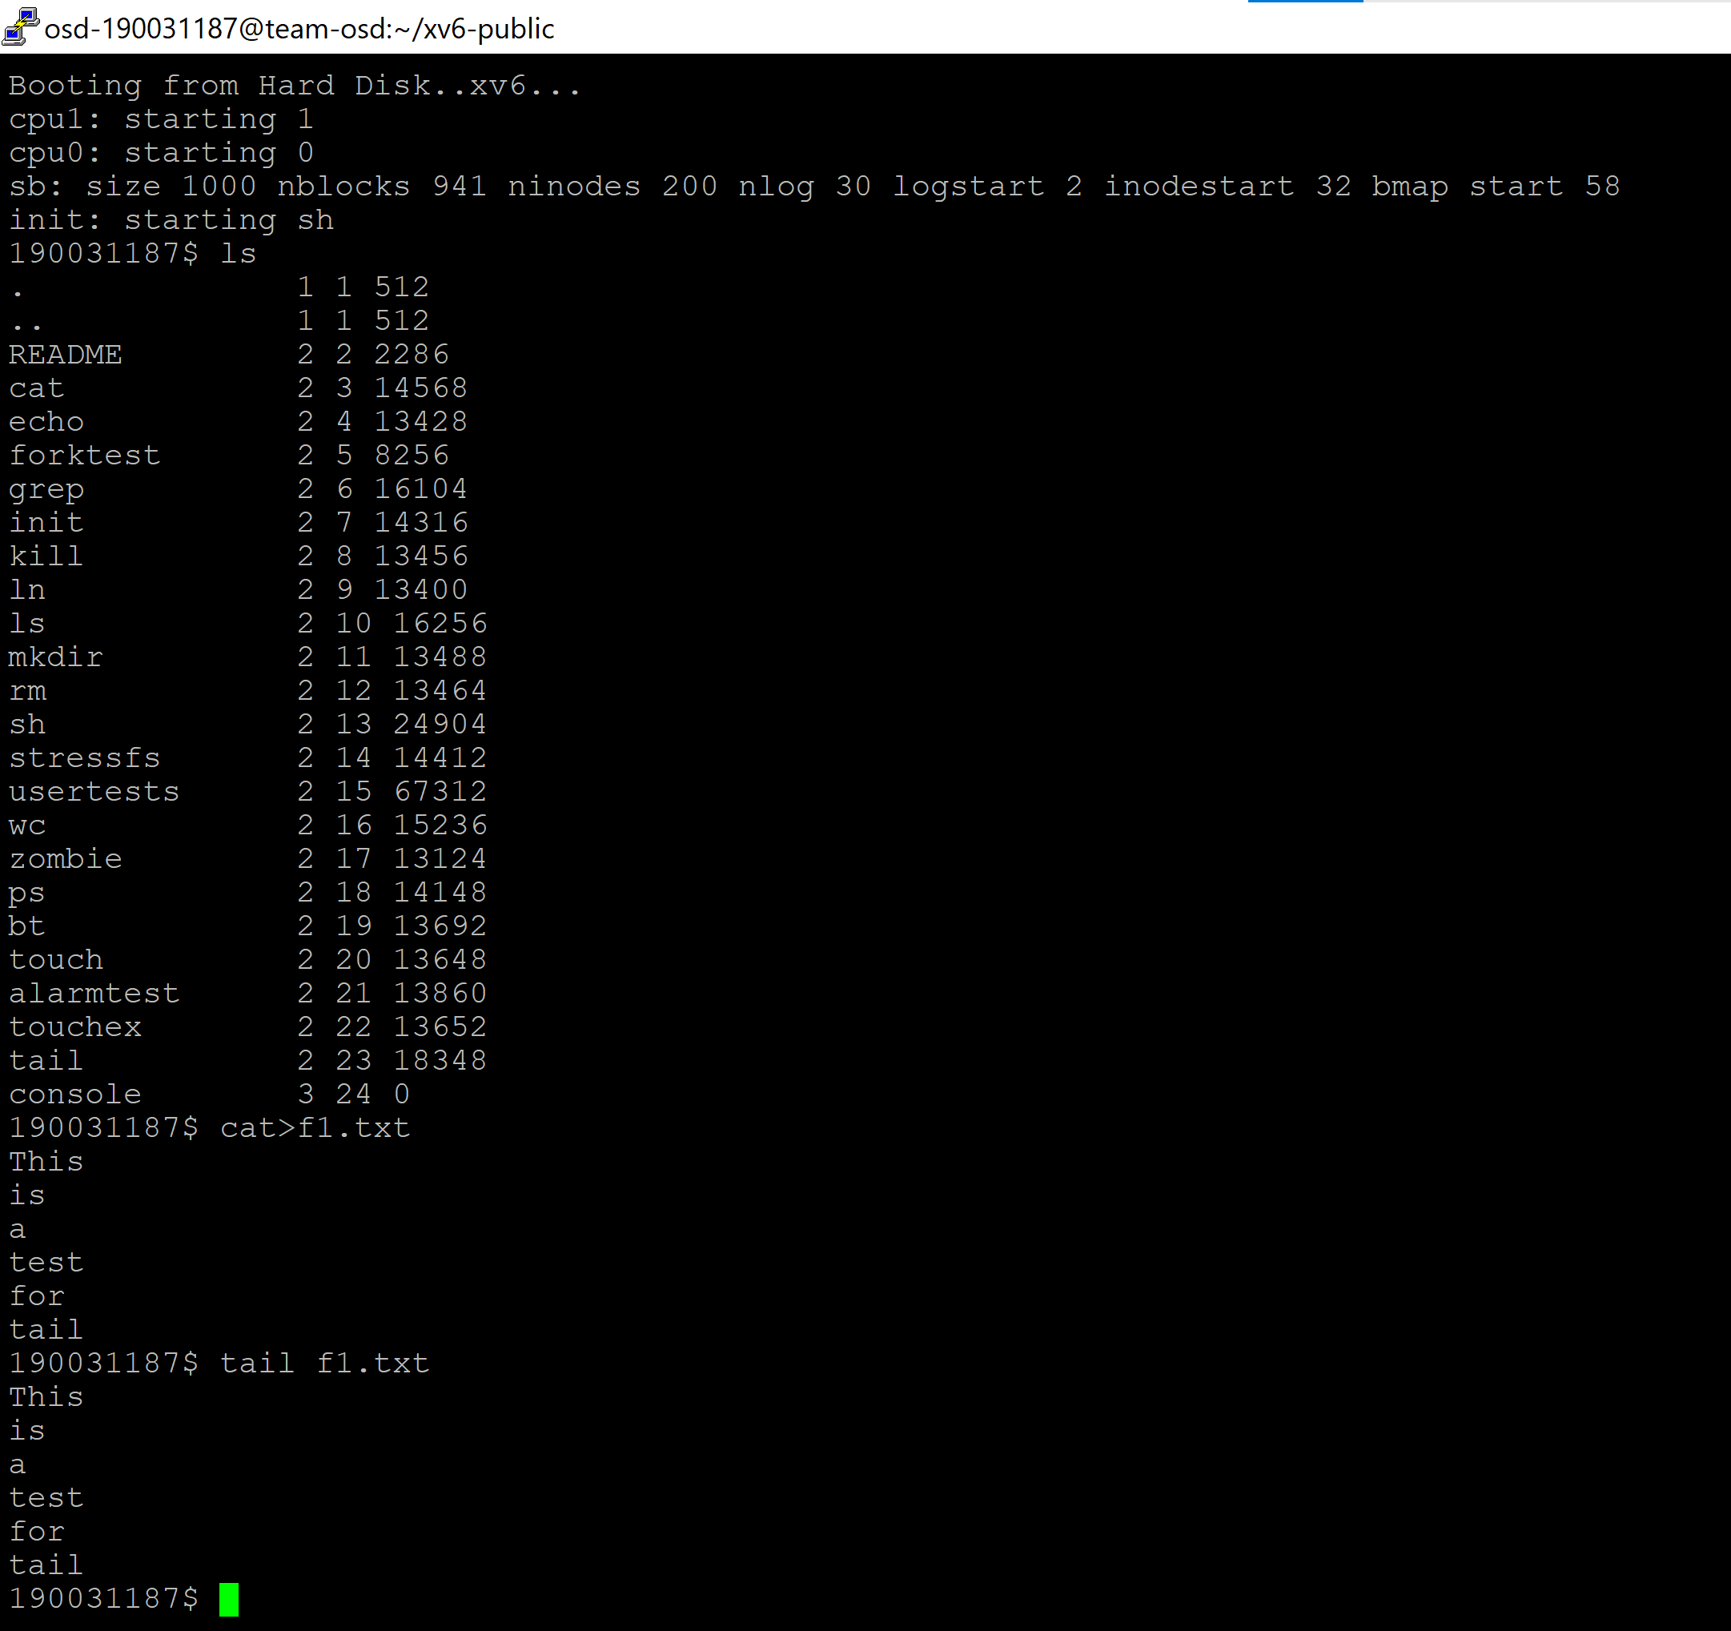

**UNIX system programming**

**1.lseek: Positioning the Offset**

#include “param.h”

#include "types.h"

#include "stat.h"

#include "user.h"

#include "fs.h"

#include "fcntl.h"

#include "syscall.h"

#include "traps.h"

#include "memlayout.h"

int

main(int argc, char *argv[]) {

int fp;

char *buffer = 0;

uint len;

if (argc != 5) {

printf(1, "usage: ./lseek1 <filename> <offset>\<len> <string>\n");

exit();

}

if ((fp = open(argv[1], O_RDONLY)) < 0) {

printf(1, "unable to open file %s\n", argv[1]);

exit();

}

len = atoi(argv[3]);

if ((buffer = (char *)malloc(len + 1)) < 0) { printf(1, "unable to allocate buffer\n");

exit();

}

int offset = atoi(argv[2]);

int ret;

ret = lseek(fp, SEEK_SET, offset);

if (ret < 0) {

printf(1, "unable to lseek\n");

exit();

}

read(fp, buffer, len); buffer[len] = 0;

printf(1, "(%s:%s)\n", argv[4], buffer);

if (strcmp(buffer, argv[4])) { printf(1, "strings do not match\n");

exit();

}

printf(1, "strings match\n");

exit();

}

Step 1: nano fcntl.h,

add the following

#define SEEK_SET 0x001

#define SEEK_CUR 0x002

#define SEEK_END 0x003

Step 3: open syscall.c and add

extern int sys_lseek(void)

[SYS_lseek] sys_lseek,

Step 4: open syscall.h and add

#define SYS_lseek 22

Step 5: open sysfile.c and add the following code

uint sys_lseek(void)

{

struct file *f;

int offset;

uint whence;

if (argfd(0, 0, &f) < 0 || argint(2, &offset) < 0 || argint(1, (int *)&whence) < 0)

return -1;

if (f->type != FD_INODE)

return 0;

uint offset_temp; uint filesize;

ilock(f->ip);

filesize = f->ip->size;

iunlock(f->ip);

switch(whence) {

case SEEK_SET: offset_temp = 0;

break;

case SEEK_CUR: offset_temp = f->off;

break;

case SEEK_END: offset_temp = filesize;

break;

default: return -1; break; } // xv6 read and write do not account for 'holes'

// so better not allow exceeding the bounds

if (((offset_temp + offset) < 0 ) || ((offset_temp + offset) >=filesize))

return -1;

f->off = offset_temp + offset;

return f->off;

}

Step 6: open user.h and add

int lseek(int fd, int offset, int whence);

Step 7: open usys.S and add

SYSCALL(lseek)

Step 8: add _lseek in Uprogs and lseek.c in Extras in Makefile

Step 9: make qemu-nox

**OUTPUT**

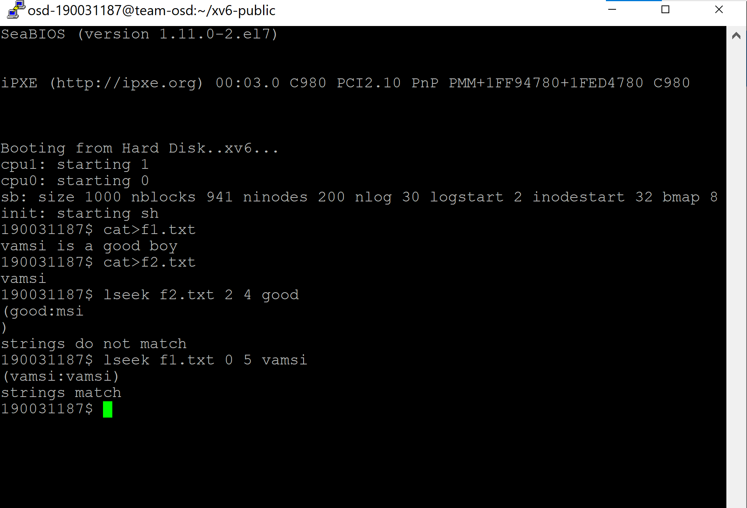

**2. Pointerreverse_read.c: Reading a File in Reverse**

#include <stdio.h>

#include <stdlib.h>

int main(int argc, const char * argv[]) {

FILE *file;

file = fopen("./oz.txt", "r+");

if (file == NULL)

{

printf ("Error - Couldn't open file\n");

}

fseek(file, 0, SEEK_END); // move file pointer to end of file

long size = ftell(file); // file pointer position == character count in file

fseek(file, 0, SEEK_SET); // move back to beginning of file

char* buffer = (char*) malloc(size * sizeof(char));

fread(buffer, sizeof(char), size, file); // read file contents to buffer

for(long i = 0; i < size/2; ++i)

{

buffer[i] = buffer[size-i-1];

}

fseek(file, 0, SEEK_SET);

fwrite(buffer, sizeof(char), size, file); // Write reverted content

free(buffer);

fclose(file);

return 0;

}